Разработка урока по английскому языку
в 8 классе к УМК Spotlight 8
“Packaging and recycling”

Составила: Николенко Е.С.
Учитель английского языка
МОУ-МАЛЕЕВСКАЯ СОШ

г.о. Клин - 2022

Тема урока: Переработка и упаковка.
Базовый учебник: Ваулина, Эванс. Английский в фокусе. 8 класс («Spotlight»). Москва, «Просвещение», 2019 г.
Цели:
Образовательная цель: расширять кругозор у учащихся в рамках изучаемой учебной ситуации(глобальные проблемы экологии).
Развивающая цель: способствовать развитию умения делать краткие сообщения на английском языке, описывать изучаемые явления, проводить самостоятельный поиск необходимой информации, обучать и делать выводы и обобщения по основным проблемам темы.
Воспитательная цель: развивать приёмы сотрудничества и взаимодействия в групповой работе, развивать самостоятельность в учебной деятельности, прививать чувство любви и бережного отношения к окружающей среде, чувство ответственности за место , где ты живёшь.
Грамматический материал: Present Simple.
Лексический материал: collect the rubbish, a rubbish bin, recycled boxes, a red recycled box, a blue recycled box, a green recycled box.
Тип урока: Изучение и первичное закрепление новых знаний.
Форма работы: в группах, в парах, самостоятельная работа.
Планируемые образовательные результаты:
предметные: совершенствовать коммуникативно-речевое развитие учащихся через соотношение графической формы ЛЕ с их значением, восприятие новых ЛЕ в контексте, осознание значения новых ЛЕ, имитацию фраз с новыми ЛЕ.
метапредметные: научить структурировать учебный материал, выделять главное и второстепенное;
личностные: формировать положительное отношение к фактам экологии, воспитывать готовность к коллективному творчеству.
Оборудование: учебник, компьютер, мультимедийный проектор, презентация, политическая карта России, магниты, упаковки для работы, раздаточный материал: текст.

Ход урока:
1. Приветствие, сообщение целей урока.
Good morning, boys and girls! I am glad to see you. How are you? Today we are going to continue talking about the environmental problems. Every year many countries get rid of millions of tons of rubbish, but this rubbish can be useful. Please watch the video and be ready to tell us the topic of our lesson. Don't forget about the words which are concerned with our topic.
Видео http://www.dailymotion.com/video/x1zcvv3_peppa-pig-recycling-with-subtitles_tech
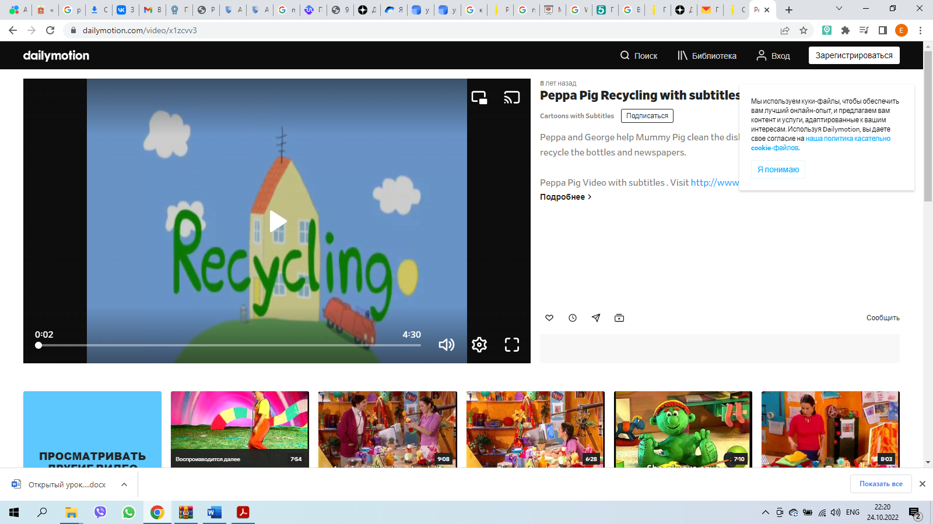
Our today's topic is" Recycling and Packaging". We shall speak about ecology, pollution, an influence of a man on the environment. What would you like to learn at the lesson?
2. Активизация лексического материала.
Please look at the blackboard. Let's translate these words.
collect the rubbish -
a rubbish bin -
recycled boxes -
a red recycled box - newspapers
a blue recycled box - tin cans
a green recycled box - bottles.
How do you think there are factories for recycling in Russia? (Pupils’ answers).
Where are they? (Pupils’ answers).

We often go shopping and buy some food, perfumes, drinking. Nowadays everything is in packages. What types of packages do you know? (bags, bottles, boxes, cans, jars, packages, rolls, tubes)
3. Работа в группах.
Let's work in groups. Look at the sheets of paper. The first group will read the first text. It is called "Why throw away so much?». The second group will read the second text "Packaging". Then you can change the ideas. Pay attention to the questions and be ready to answer these questions. You can discuss 10 minutes.
The first text:
1. How many kilos of paper does an European family throw away?
2. What can we learn from the Green World reports?
3. What kind of material can be burned or recycled?
4. Is recycling cheap for our government?
5. What does it save?
The second text:
1. Is the packaging is necessary for us? Why?
2. How many kilos of plastic wastes does each person produce every year?
3. What kind of litter do some people throw away?
4. What can you see in the town and in the countryside?
5. How can the litter harm farmer animals?
4. Физкультминутка.
Stand up, please.
Boys, hands up.
Boys, hands down.
Boys and girls, turn around.
Girls, hands up.
Girls, hands down.
Girls and boys, turn around.
Stand up, please.
Boys, hands up.
Boys, hands down.
Boys and girls, turn around.
Girls, hands up.
Girls, hands down.
Girls and boys, turn around.
https://www.youtube.com/watch?v=WsiRSWthV1k
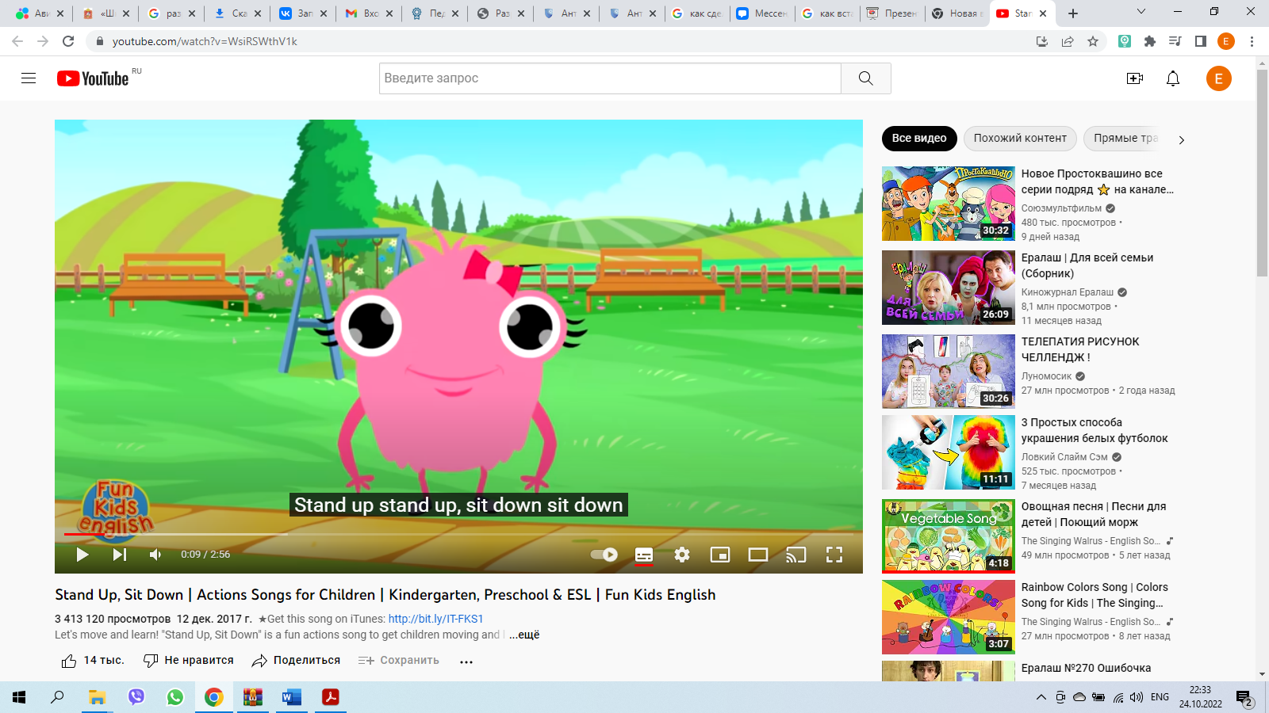
5. Выбор упаковки: пластиковый пакет или бумажный.
You go shopping every day. What do you prefer : plastic bag or paper bag? Please go to my place and make a choice.
6.Выполнение тестовых заданий.
How do you think the waste left by peoples harm the soil? Let's do the test.
Презентация http://www.myshared.ru/slide/991057/
Слайды 11-18
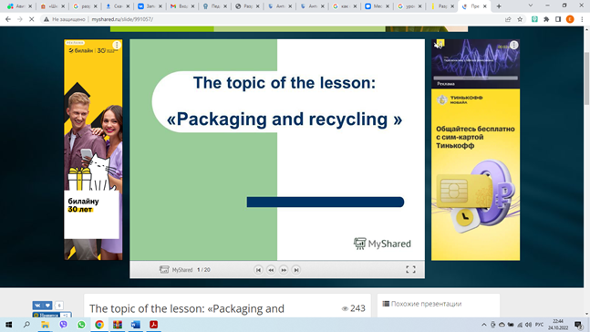
7. Выполнение проекта. Творческое применение и добывание знаний в новой ситуации (проблемные задания)
What environmental problems are there in Russia?
What disasters can they lead to? (какие бедствия)
Now you will divide into 3 groups and show how it is possible to prevent environmental pollution.
(раздаю каждой группе пластиковую бутылку, пакет, коробку из под сока. Ребятам нужно показать, что можно сделать из этого)
It’s time. Please, demonstrate your project.
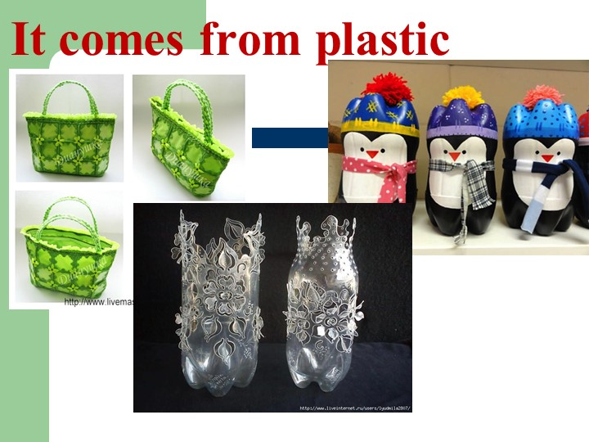
8. Объяснение домашнего задания.
Ex. 1 p. 38
9. Рефлексия. Подведение итогов урока
I can...
I can't...
The lesson is over. Your marks are ...Good bye.

Приложение
Why throw away so much?
Many countries bury and forget about millions of tons of rubbish every year It is known that in one year, a European family with two children throws away about 50 kilos of paper (that's six trees), and about 60 kilos of plastic.
The Green World reports say that in one year the average person throws away: about 70 food cans, 34 cans of pet food and about 70 drink cans.
But we don't have to throw away all our waste paper, glass, metal and plastic. We can also burn or recycle a lot of it. In fact waste can be wonderful stuff.
Many things that we throw away can still be useful. In fact it's possible to recycle &0% of domestic rubbish. We can recycle most kinds of paper, glass, metal and plastic. But only 4% of recyclable material is actually recycled. Recycling is expensive. But it saves trees and energy and protects the environment from pollution.
Packaging
These days, people usually do shopping in supermarkets. Nearly everything is packed in paper or plastic containers. Some of this "packaging" is necessary. It keeps food clean and fresh. But some packaging is not necessary. Its just to make the food look better.
Every year in Britain each person produces about 57 kilograms of plastic waste.
Disposing of all this plastic is an expensive problem. But that's not all. Making plastic causes pollution.
Unfortunately, some of this packaging doesn't reach the bins. It becomes litter instead. Some people simply tear the wrapping off sweets and throw it away. They drop their cigarette packets and cans of drink without a thought.
In the town their litter looks horrible. But fortunately someone clears it away. In the country side, it remains in the fields and on the roadsides unless the people who live nearby pick it up. It can kill or hurt farm animals. Bottles and cans cause cuts, and the animals can eat polythene bags and die, or put their heads in them and suffocate.

